MODULE 2

Data Warehouse Design – Analytical Operations of OLAP
AIM
To perform analytical operations of Online Analytical Processing (OLAP) such as Roll-up, Drill-down, Slicing, Dicing and Pivot on a multidimensional data model using Microsoft Excel.
PROCETURE
In a multidimensional data model, data is organized into fact tables and dimension tables.The fact table contains measurable data such as total sales amount, quantity, tax, etc., while the dimension tables describe the context of the data such as product, date, payment type, location and order status.Using this structure, data can be analyzed at different levels of detail by applying OLAP operations.
STEP 1: IDENTIFYING FACT AND DIMENSION TABLE
The dataset was preprocessed and organized into the following tables:
- Fact Table: fact_orders
Contains order_id, date_id, customer_id, product_id, location_id, payment_id, order_status_id and measures such as quantity, unit_price, discount, tax, shipping_cost and total_amount.
- Dimension Tables:
  - dim_date
  - dim_customer
  - dim_product
  - dim_location
  - dim_payment
  - dim_order_status
These tables together form a Star Schema, which is suitable for OLAP analysis.
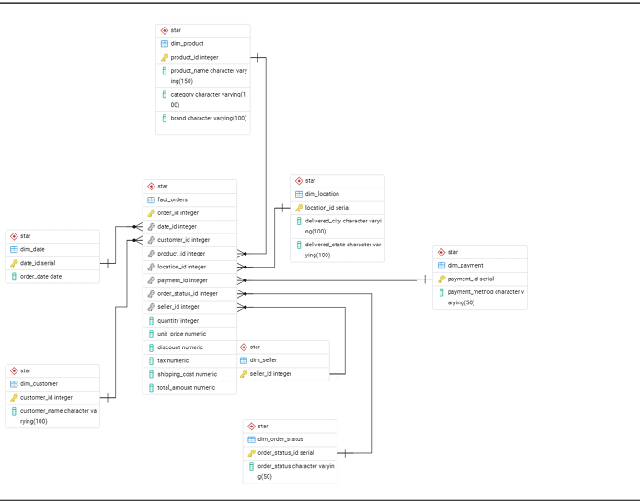
Fig. 2.1 Star Schema showing Fact and Dimension Tables
STEP 2: DIMENSION HIERARCHIES
A dimension hierarchy defines logical levels within a dimension that support drill-down (more detail) and roll-up (summary) analysis in OLAP systems. These hierarchies enable multi-level business insights from Amazon sales data.
1. Date Dimension Hierarchy (dim_date)
Hierarchy Name: Time Analysis Hierarchy
Hierarchy Levels:
Year
↓
Quarter
↓
Month
↓
Order Date
Explanation:
This hierarchy helps analyze sales trends over time, identify seasonal patterns, evaluate discount timing, and support revenue forecasting.
Key Use Cases:
- Monthly and yearly revenue analysis
- Seasonal demand identification
- Price drop and discount cycle analysis
2. Customer Dimension Hierarchy (dim_customer)
Hierarchy Name: Customer Segmentation Hierarchy
Hierarchy Levels:
Customer Risk Category
↓
Customer Purchase Frequency
↓
Customer
Explanation:
This hierarchy enables analysis of customer behavior, return patterns, and risk profiling, supporting fraud detection and customer clustering.
Key Use Cases:
- High-risk vs low-risk customer identification
- VIP, budget, and occasional buyer segmentation
- Return behavior analysis
3. Product Dimension Hierarchy (dim_product)
Hierarchy Name: Product Classification Hierarchy
Hierarchy Levels:
Category
↓
Brand
↓
Product
Explanation:
This hierarchy helps analyze product-level performance, detect product cannibalization, optimize discounts, and improve inventory decisions.
Key Use Cases:
- Category-wise revenue contribution
- Cannibalization detection between similar products
4. Location Dimension Hierarchy (dim_location)
Hierarchy Name: Geographic Sales Hierarchy
Hierarchy Levels:
Country
↓
State
↓
City
Explanation:
This hierarchy supports regional performance analysis, logistics cost optimization, and identification of high-profit and low-profit delivery zones.
Key Use Cases:
- City/state-wise shipping cost analysis
- Regional sales performance
5. Payment Dimension Hierarchy (dim_payment)
Hierarchy Name: Payment Method Hierarchy
Hierarchy Levels:
Payment Type
↓
Payment Method
Explanation:
This hierarchy helps analyze payment preferences and ensures fair fraud risk modeling without bias toward specific payment methods.
Key Use Cases:
- COD vs online payment analysis
- Cancellation and return pattern detection
- Fair fraud risk assessment
6. Order Status Dimension Hierarchy (dim_order_status)
Hierarchy Name: Order Fulfillment Hierarchy
Hierarchy Levels:
Order Outcome
↓
Order Status
Explanation:
This hierarchy enables analysis of delivery success, cancellations, and returns to reduce fraud and improve fulfillment efficiency.
Key Use Cases:
- Delivered vs returned order comparison
- Cancellation prediction
- Return fraud analysis
7. Seller Dimension Hierarchy (dim_seller)
Hierarchy Name: Seller Performance Hierarchy
Hierarchy Levels:
Seller Performance Category
↓
Seller

Explanation:
This hierarchy helps evaluate seller-level performance, revenue contribution, and operational efficiency.
Key Use Cases:
- High-performing vs low-performing sellers
- Seller revenue forecasting
- Seller-based logistics optimization
STEP 3: HIERARCHY COLUMNS WITH MEASURES/TARGETS
Product Dimension Hierarchy
Hierarchy: Category → Brand → Product
Category | Brand | Product | Avg Quantity Sold | Avg Discount | Avg Total Amount
Electronics | Samsung | P101 | 12 | 10% | 18,500
Electronics | Apple | P102 | 8 | 5% | 65,000
Measures / Targets:
- Average Quantity Sold
- Average Discount Percentage
- Total Revenue
Location Dimension Hierarchy
Hierarchy: Country → State → City
Country | State | City | Avg Shipping Cost | Total Sales
India | Tamil Nadu | Chennai | 120 | 2,50,000
India | Karnataka | Bengaluru | 135 | 3,10,000
Measures / Targets:
- Average Shipping Cost
- Total Sales Amount
Combined Fact Table View
Order ID | Date | Product | Category | City | Payment Method | Quantity | Total Amount | Order Status
O101 | 2024-01-12 | Laptop | Electronics | Chennai | UPI | 1 | 55,000 | Delivered
O102 | 2024-01-15 | Shoes | Fashion | Bengaluru | COD | 2 | 3,200 | Returned

OLAP OPERATIONS:
ROLL-UP Operation
1. Goal: To see overall trends instead of individual transactions.
Columns:
- payment_id
- total_amount
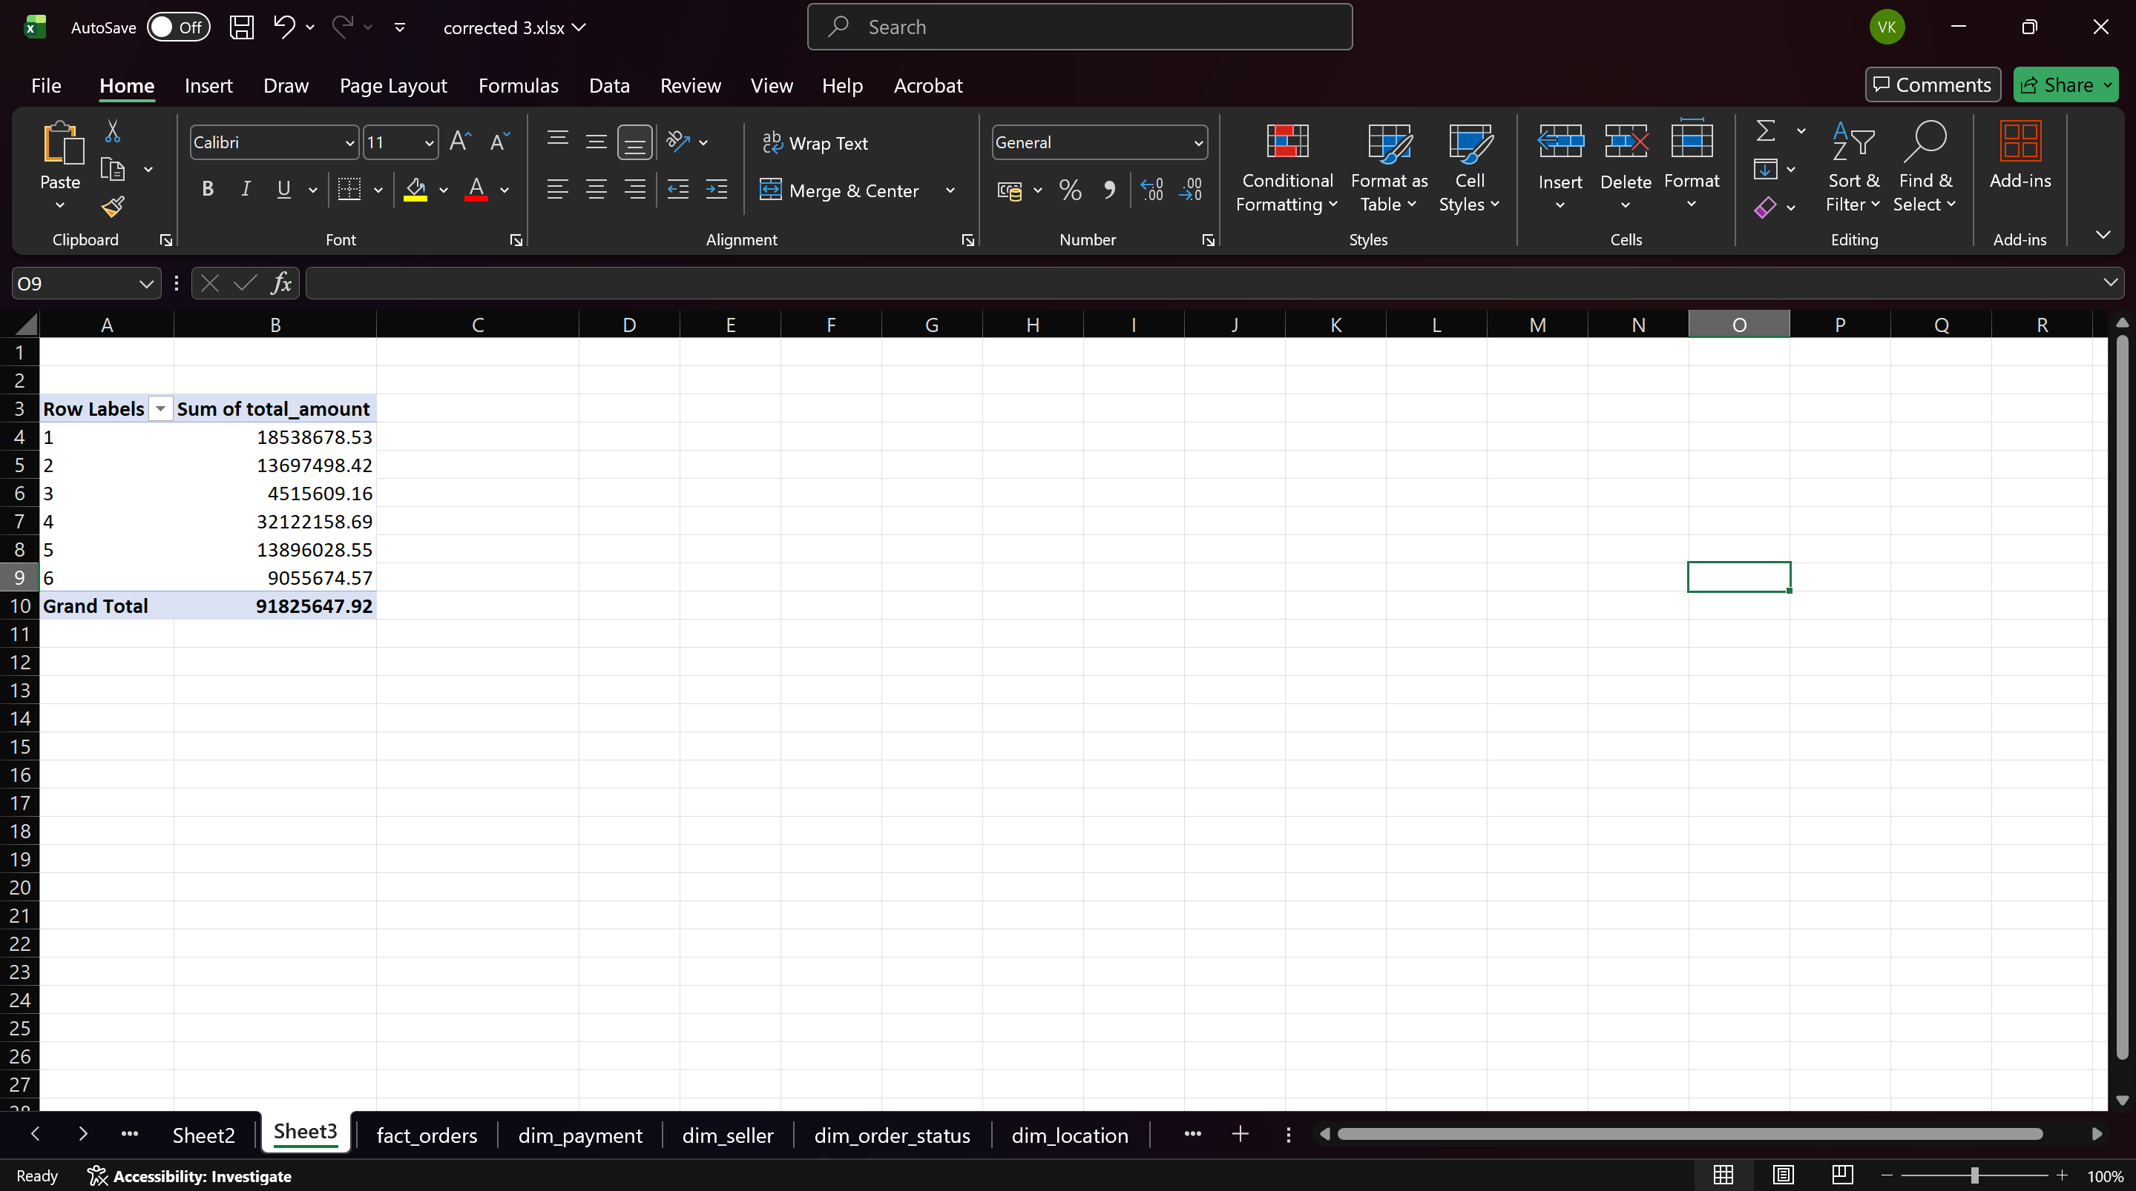
Fig. 2.2 Roll-up operation showing total sales grouped by payment_id
2. Goal: Sales data is summarized at the product level, which helps identify high-selling products.
Columns:
- product_id
- total_amount
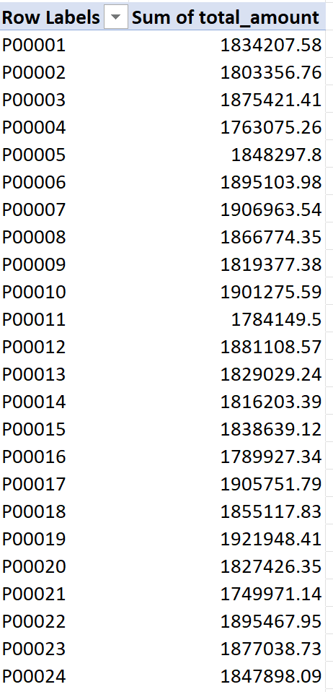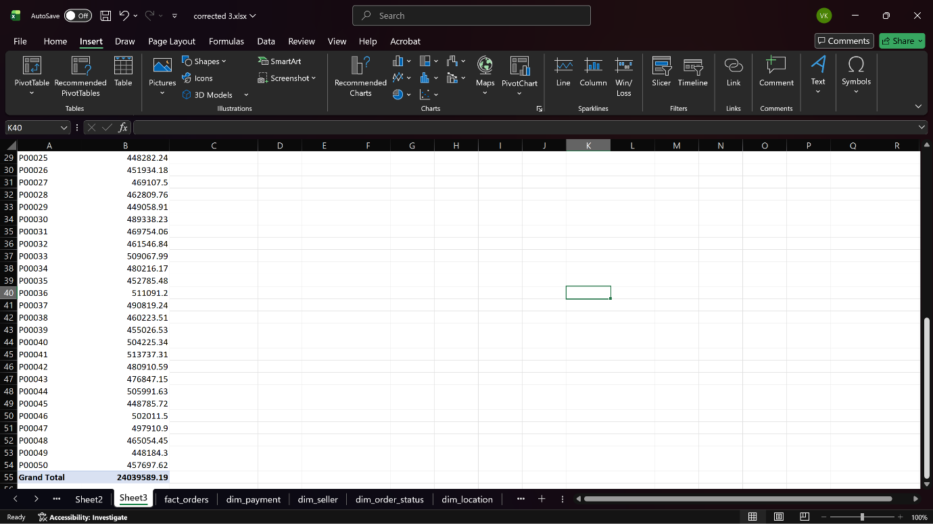
Fig. 2.3 Roll-up operation showing total sales grouped by payment_id
DRILL-DOWN Operation
Drill-down is the reverse of roll-up. It moves from summarized data to more detailed data.
1. Goal: To investigate details behind summarized data.
Columns:
- payment_id
- order_status_id
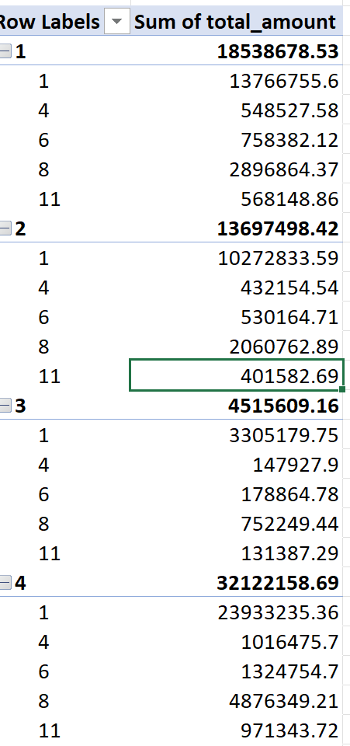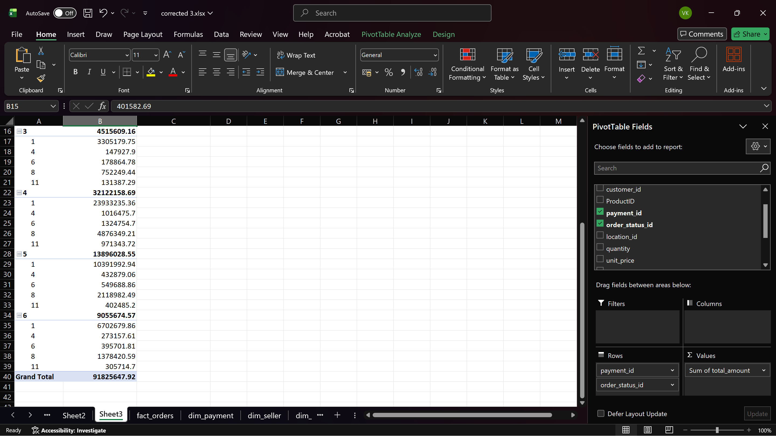
Fig. 2.4 Drill-down operation showing order status under each payment type
2. Goal: To provides detailed insight into product-wise order outcomes.
Columns:
- product_id
- order_status_id
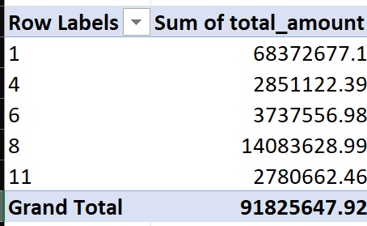
Fig. 2.5 Drill-down operation showing order status under each product

SLICING Operation
Slice operation selects a single value of one dimension, creating a smaller sub-cube.
In this operation, data was sliced by selecting order_status_id = 1, which filters the data to show sales related to a specific order status only.
1. Goal: To focus analysis on one specific condition.
Columns: order_status_id
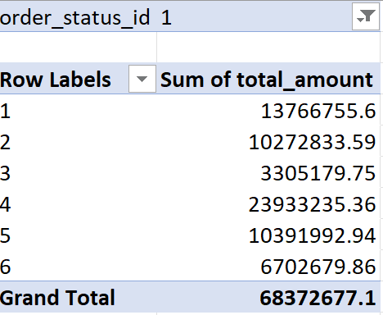
Fig. 2.6 Slice operation for order_status_id = 1
2. Goal: This focuses analysis on one specific product.
Columns:
- product_id
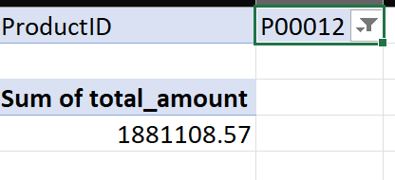
Fig. 2.7 Slice operation for a single product

DICING Operation
Dice operation selects data based on multiple conditions across dimensions.
1. Goal:
To analyze data under multiple filters together.
Columns:
- order_status_id = 1
- payment_id
- product_id
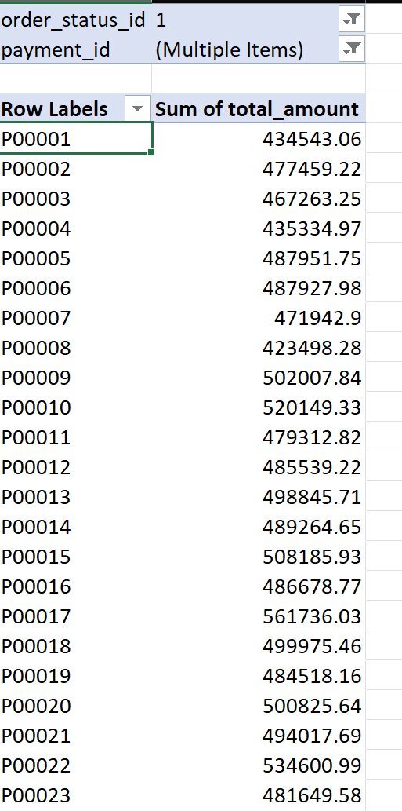
Fig. 2.8 Dice operation using order_status_id and payment_id
2. Goal: To creates a smaller sub-cube using multiple conditions.
Columns:
- product_id
- payment_id
- order_status_id
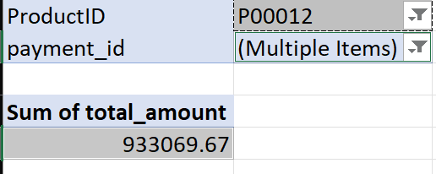
Fig. 2.9 Dice operation using product and payment type
PIVOT Operation
Pivot (Rotate) operation changes the orientation of data axes to view data from different perspectives.
1. Goal: To view the same data from a new perspective.
Columns:
- product_id
- payment_id
- total_amount
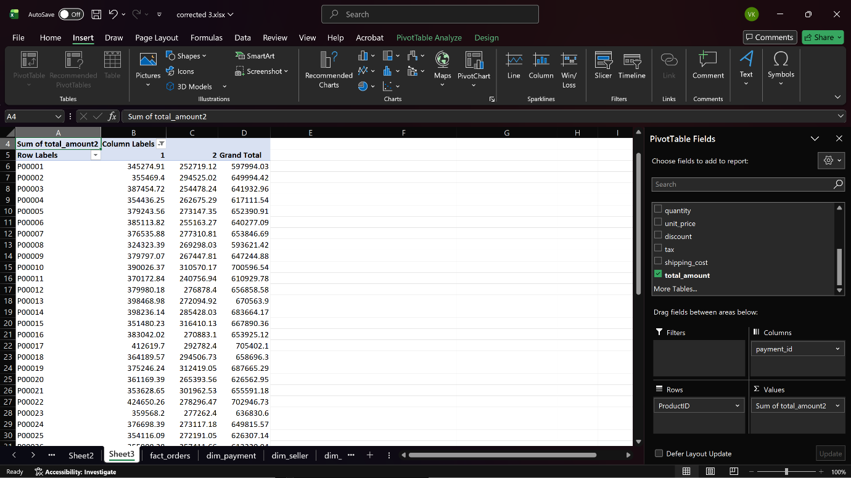
Fig. 2.10 Pivot operation showing product-wise sales across payment types
2. Goal: Pivot helps compare multiple dimensions side by side.
Columns:
- order_status_id
- payment_id
- total_amount

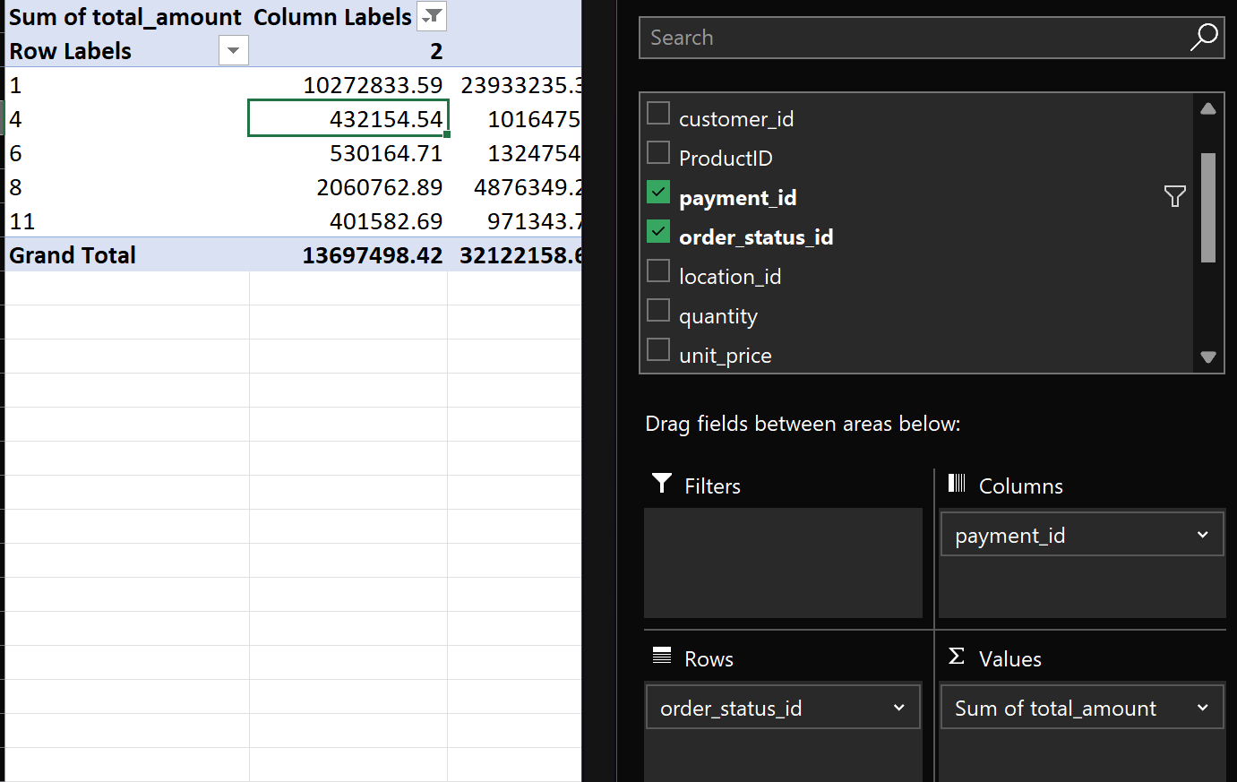
Fig. 2.11 Pivot operation showing order status vs payment type

